 

**Name: ______________________________ GRADE: 2 SUB: MATHS**

**Use a ruler, connect the dots to draw the shapes shown.**

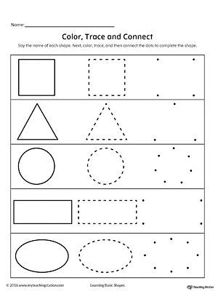

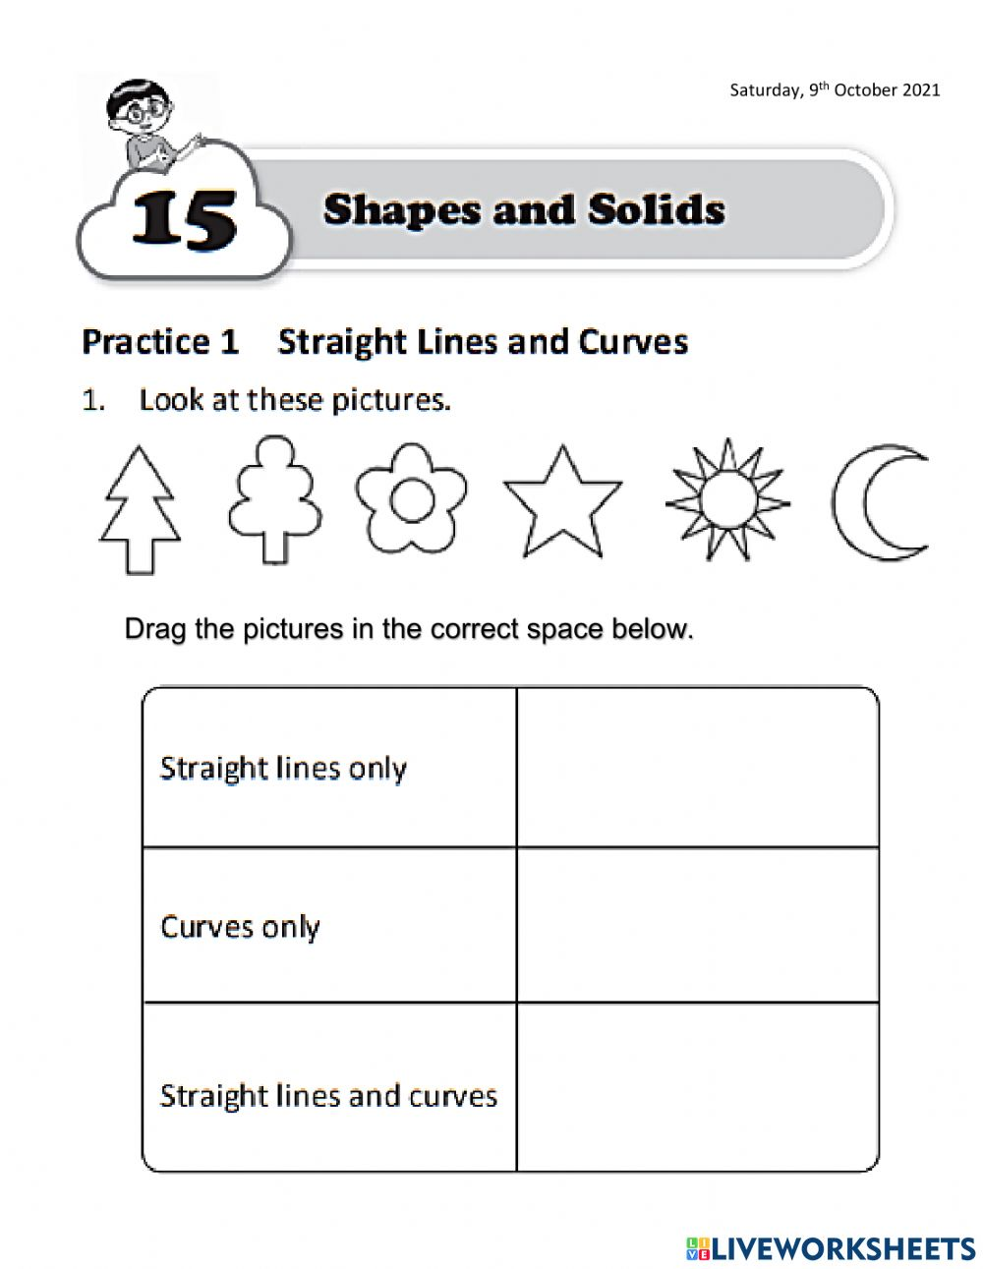

**Draw the pictures in correct box**



